Movie mate template

Initial loading screen as soon as the app is tapped on

First screen is extremely simple, just showing the app’s logo and our developer logo

Look at the PlayStation app, the opening is bold yet simple.

Begin with a red on white color scheme for the basis of the app, then we can play around with more colors in time.



Is it possible to have a geographical option, so to sync what movies are out with the chosen country?



2

**By Liam**

The colour scheme of the app is white, grey and blacks with the functional buttons of the app in our trademark red (some of what should be red is orange because for some unknown reason word hates the colour red). We want the information to always be readable and the main component of the app, but still having the other features prominent.

Home screen for the app. Shows the biggest movies out. The rank in which they will be listed will be determined by us. Essentially whatever the biggest and hottest movie that is out at the time goes at the top. Whatever promotes efficiency.

Title is in the center for every movie. It doesn’t lean towards the movie poster and ignore the tap for more info, which is really where we want to draw the user. Also allows the eye to follow a natural downwards progression, encouraging the allure of each title.

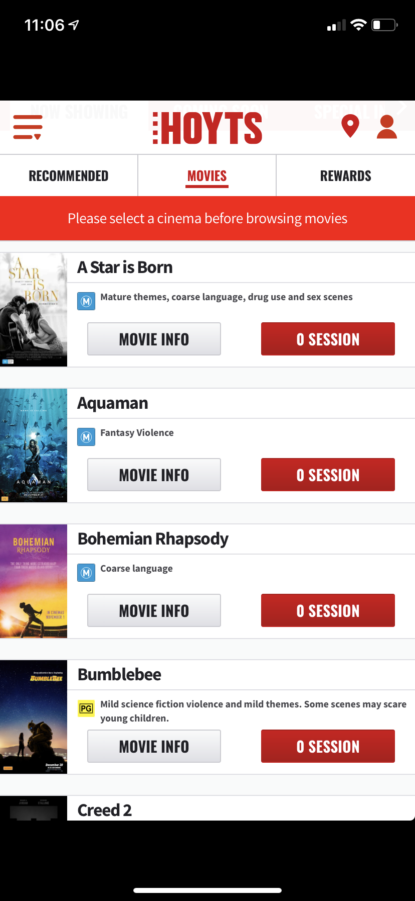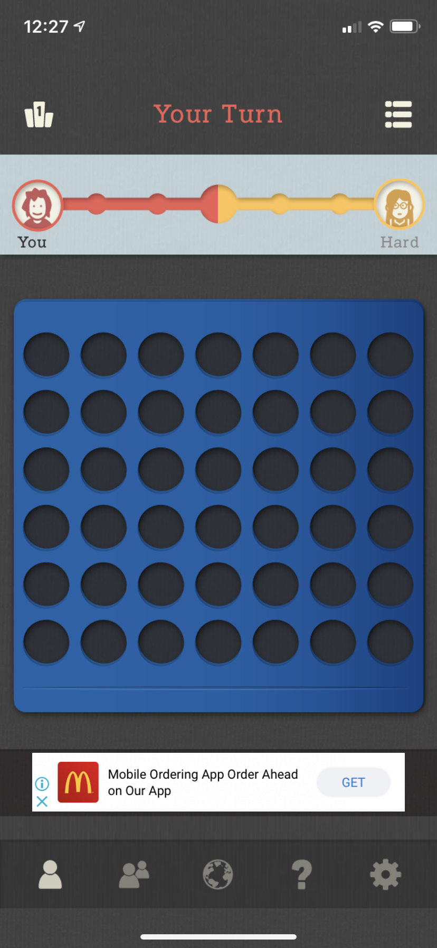

Tap for more Info

Arthur Curry (Jason Momoa) learns that he is the heir to the underwater kingdom of Atlantis and must step forward to lead his people and be a hero to the world.

A little bit of money-making implementation. However once again, we want to have the ad in there so seamlessly that people do not notice it, nor does it take away from the core information.

Seamless “tap for more info” button on the right side. A lighter color as not to distract from the information, but clean and easy to navigate.

Open to ideas on what the text is under the title and besides the movie poster. Also, the movie rating should be included but only within the information of the movie, not on the homepage

Example format for home page. Thoughts on the IMDB description with actor names then a tap for more info?

This menu bar can go at the bottom of the app, it depends on what is easier and what works the best. The aim is for it to be distinguishable, but never in the way.

Small gaps between each movie. We want as many movies as possible with minimal wasted space and crisp distinguishability between each individual movie.

A musician (Bradley Cooper) helps a young singer (Lady Gaga) find fame, even as old age and alcoholism sends his own career into a downward spiral.

Tap for more Info

Release Dates



Permanent Header with 3 features; Menu, Home and account. Should account be swapped for search and moved to under the menu

Alternative ways to rank the movies, going by release date. This is for the lower level releases but still enough to address